Scalar Subquery
Find the product with the maximum price in the store.

SQL Query
SELECT product_id, product_name, price FROM products WHERE price = (SELECT MAX(price)
FROM products);
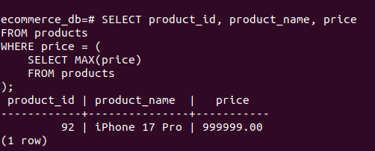

Explanation
- The scalar subquery calculates the highest product price from the products table.
- The main query then retrieves the product whose price matches this maximum value, returning the most expensive product in the store.

IN Clause
Select all users who have ordered a product related to the “Mystery” category.
Since the products table does not have a category column, product name is used for filtering.

SQL Query
SELECT DISTINCT u.user_id, u.name FROM users u JOIN orders o ON u.user_id = o.user_id
WHERE o.order_id IN ( SELECT oi.order_id FROM order_items oi JOIN products p ON oi.product_id = p.product_id WHERE p.product_name ILIKE '%TV%');

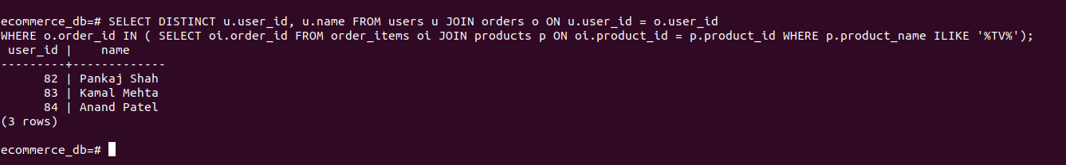

Explanation:
- The subquery selects all product IDs that belong to the Mystery category. The main query then uses the IN clause to find users who ordered any of those products. This ensures that only users who purchased Mystery-category products are selected.

